CROWD DATASET CLEANED AND FILTERED IN POWER BI: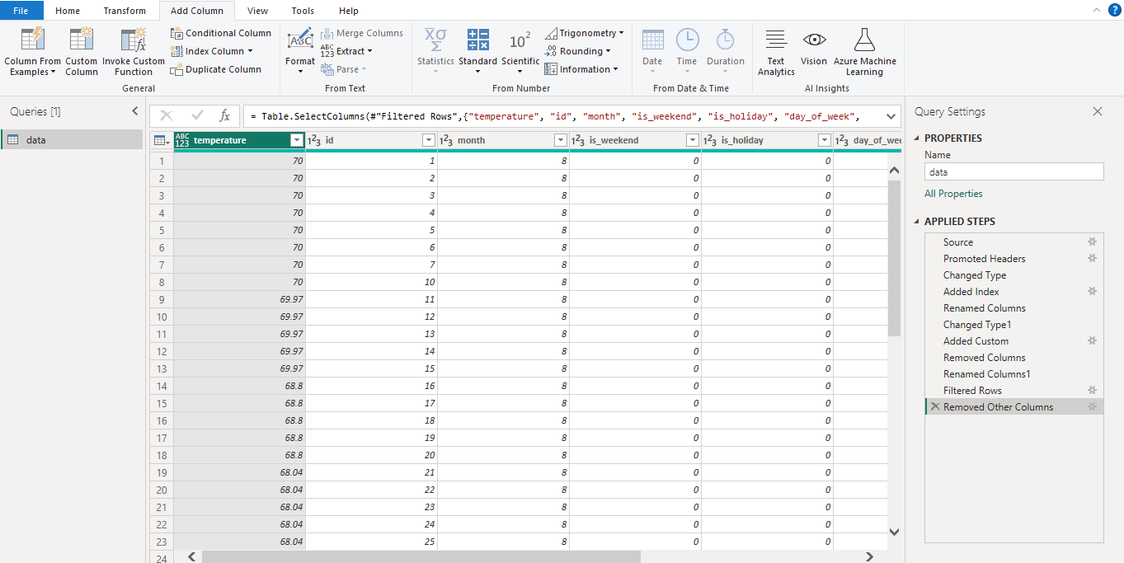

Gym dataset cleand and filter:

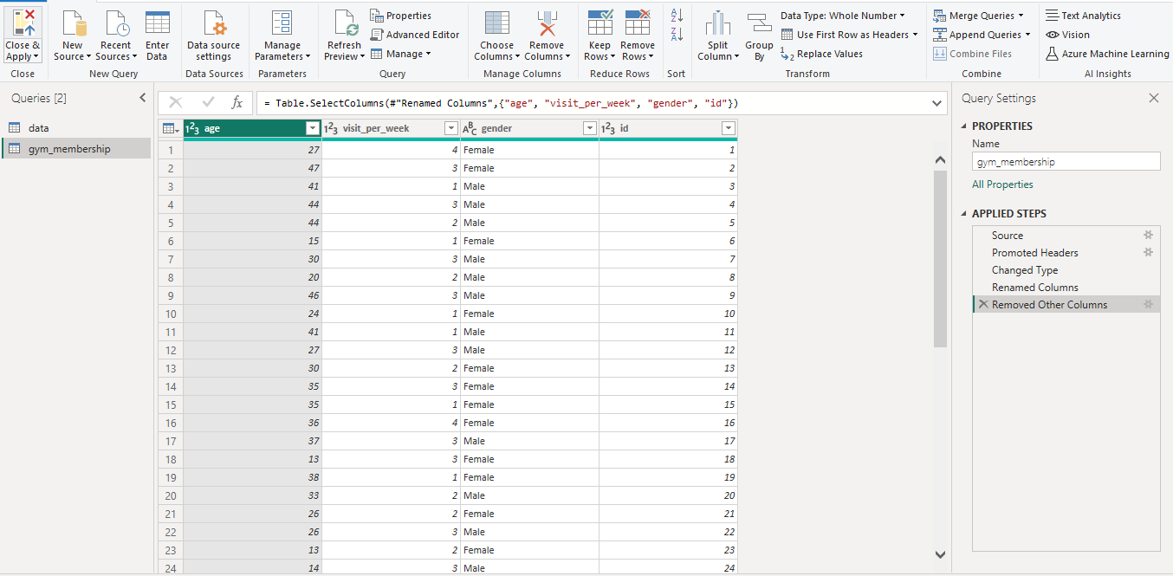

Merged and cleaned the data by filling missing age, visitperweek and gender

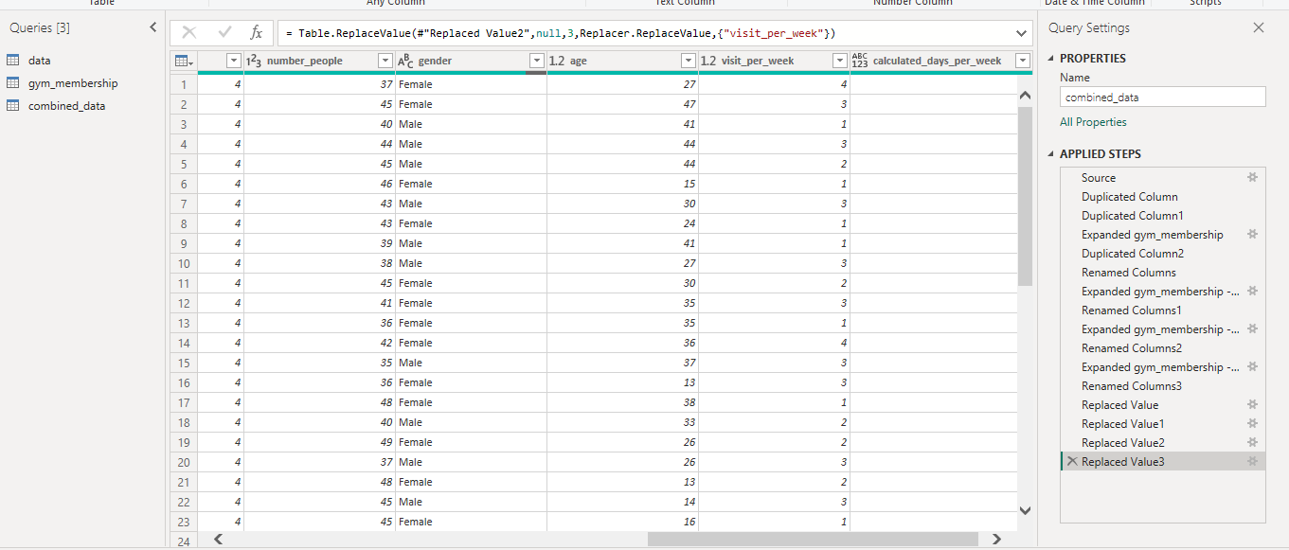

AVEG ATTEND PER SEASON:

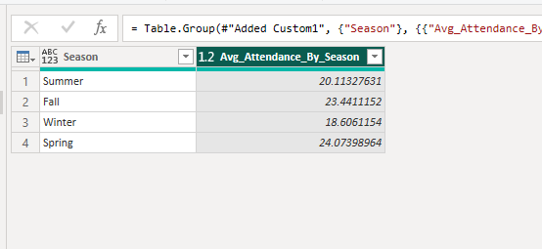

WEEKEND VS WEEKDAY ATTEND:

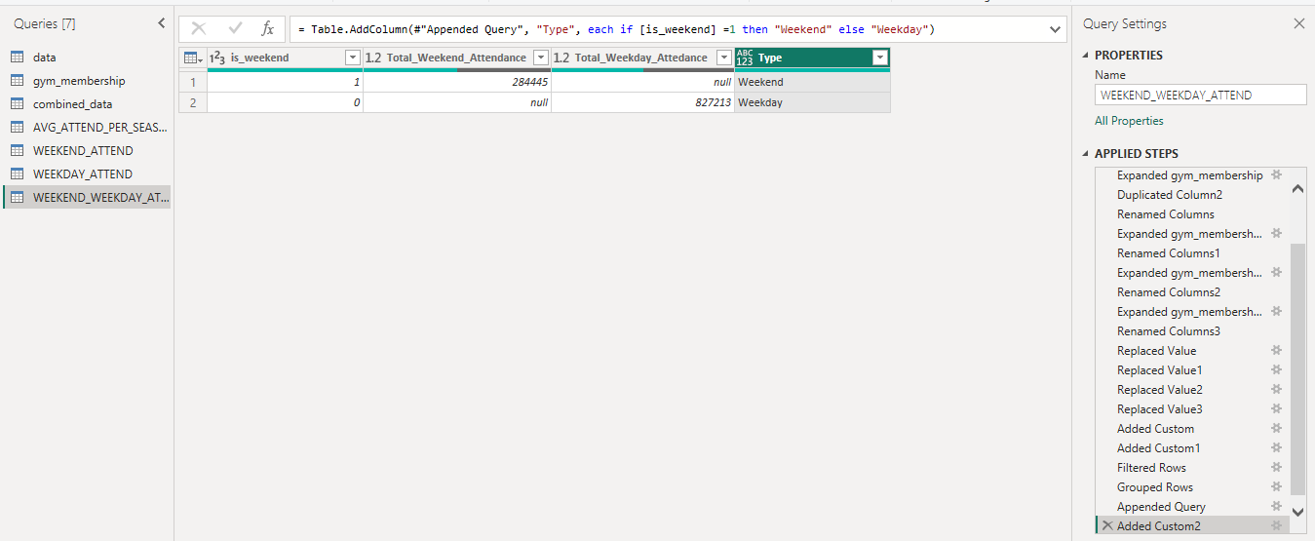

HOLIDAY ATTEND:

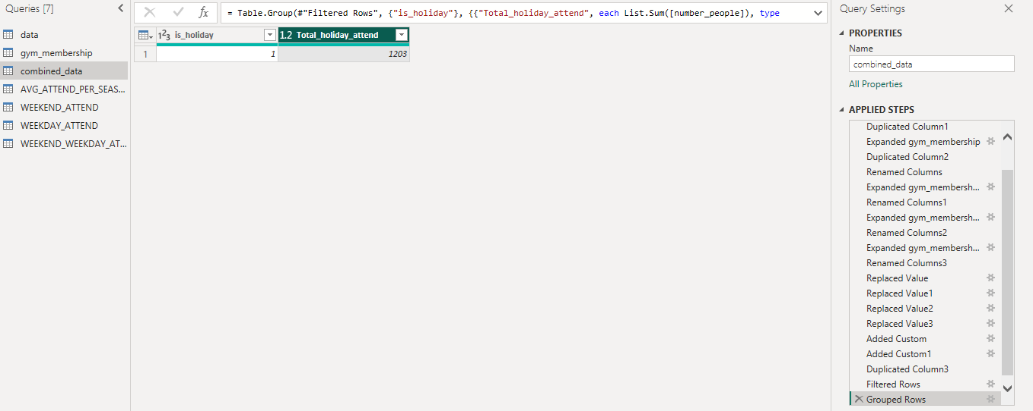

PIVOT BAR CHART:

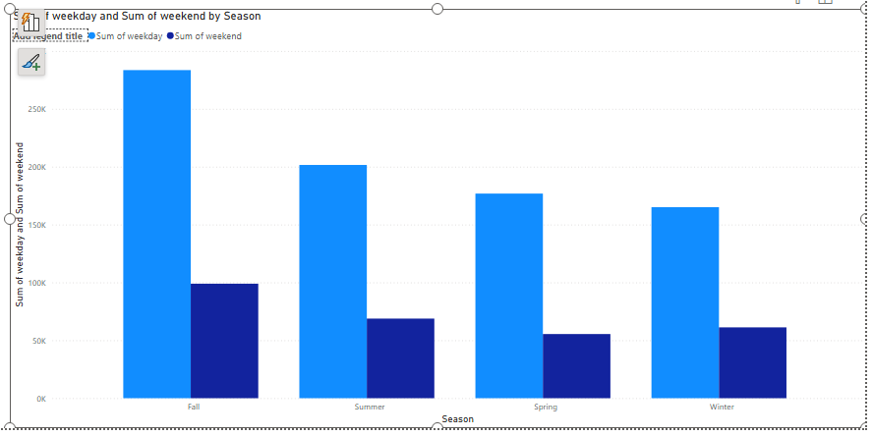

Avg gym attendance by season

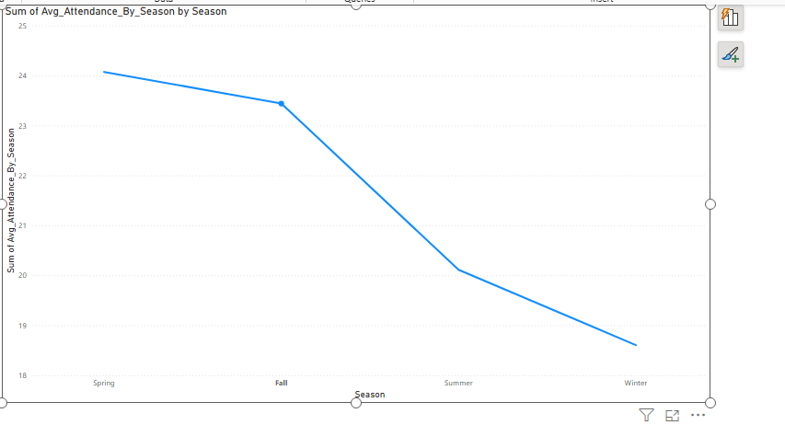

BAR CLUSTERED CHART: WEEKEND VS WEEKDAY

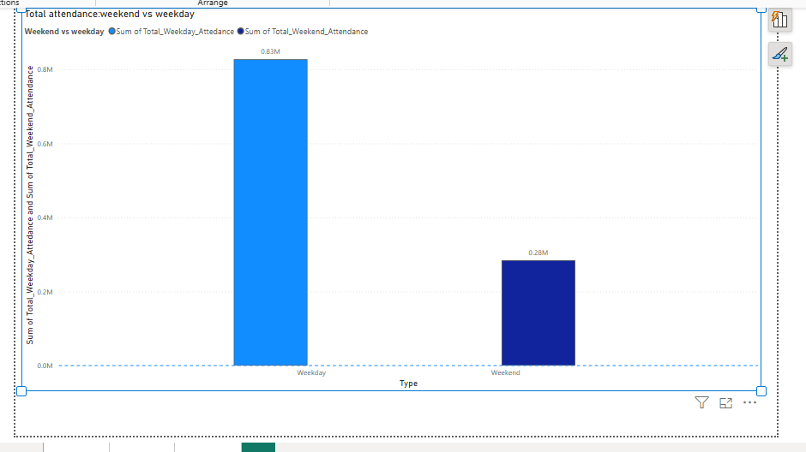

Holiday vs non holiday

